Organization Name: Initial Contact: / /
Letter/Email Sent: / /

 | ID# | Eligible |  | Referral
1 |  | Yes | No
2 |  | Yes | No
3 |  | Yes | No
4 |  | Yes | No
5 |  | Yes | No
6 |  | Yes | No
7 |  | Yes | No
8 |  | Yes | No
9 |  | Yes | No
10 |  | Yes | No
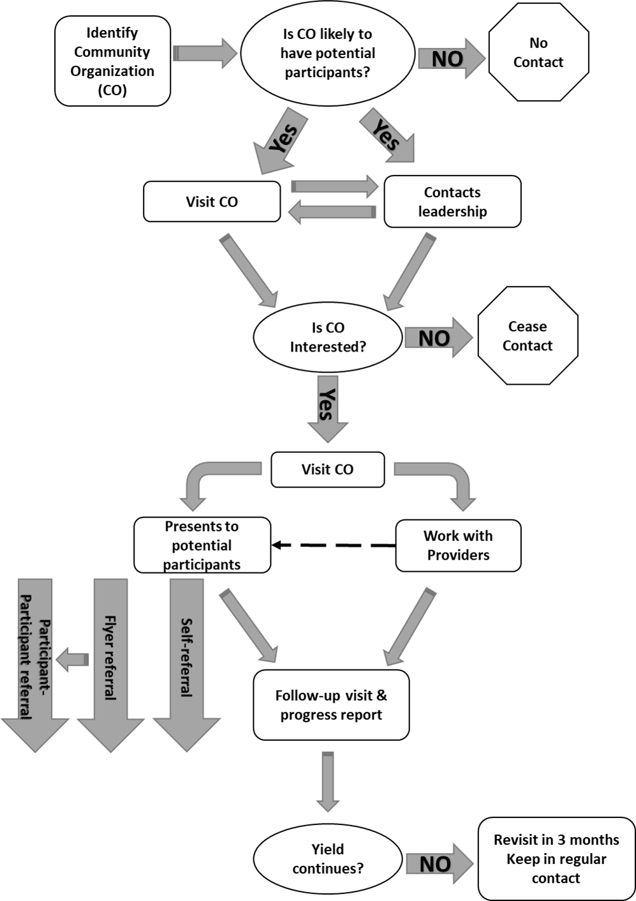
Resource Name:
Type:
Phone:
Address:
Notes:
Name:
Title:
Phone:
Instructions: Highlight each process completed and indicate completion date. Fill in information boxes. Fill in screening ID for each participant recruited from the facility and log eligibility and referral mode. DO NOT log participant identifying information other than ID#.

